**Prototype operating instructions**

**and risk & safety aspects**

**Airborne Wind Energy Take-off and Landing project**

**CHCRC project P5-650-12/02**

Change History

|  |  |  |  |
| --- | --- | --- | --- |
| **Rev.** | **Chapter** | **Description** | **Date / Dep. / Name** |
| 01 | All | Initial Document | <2015-10-30> / CH-RD.P2 / Lorenzo Fagiano  <2015-10-30> / CH-RD.P2 / Eric Nguyen-Van |
| 02 | All | Added key switch, red/green light and emergency stop button | <2015-11-25> / CH-RD.P2 / Lorenzo Fagiano |
|  |  |  |  |
|  |  |  |  |
|  |  |  |  |
|  |  |  |  |
|  |  |  |  |
|  |  |  |  |
|  |  |  |  |
|  |  |  |  |

**IMPORTANT**:

1. **DO NOT ATTEMPT TO OPERATE THE GROUND STATION WITHOUT THE PHYSICAL PRESENCE OF A TRAINED PERSON. THIS INCLUDES MOUNTING AND DISMOUNTING THE HARDWARE, CONNECTING THE ELECTRICAL PARTS, DEPLOYING AND RUNNING THE CONTROL SOFTWARE. A LIST OF TRAINED PERSONS IS REPORTED IN SECTION 4.2.**
2. **DO NOT ATTEMPT TO OPERATE THE MODEL GLIDER WITHOUT THE PHYSICAL PRESENCE OF A TRAINED PERSON. THIS INCLUDES MOUNTING AND DISMOUNTING THE GLIDER, CONNECTING THE ELECTRICAL PARTS, OPERATING THE REMOTE, ARMING THE GLIDER, TESTING THE SERVOS AND FLYING THE GLIDER. A LIST OF TRAINED PERSONS IS REPORTED IN SECTION 4.34.2.**
3. **WHEN OPERATING THE GROUND STATION WITHOUT THE GLIDER ATTACHED, A MINIMUM DISTANCE OF 1 METER HAS TO BE KEPT FROM BOTH ROTATING DRUMS.**
4. **WHEN OPERATING THE GROUND STATION WITH THE GLIDER ATTACHED AND FLYING, A MINIMUM DISTANCE OF 10 METERS HAS TO BE KEPT FROM THE GROUND STATION.**
5. **DO NOT ATTEMPT TO OPERATE THE GROUND STATION AND/OR THE GLIDER WITHOUT HAVING READ IN DETAIL THE RELATED TECHNICAL NOTE NUMBER CH-RD 2015-211.**
6. **ALWAYS WEAR SAFETY SHOES WHEN OPERATING THE PROTOTYPE.**

Table of contents

1 Prototype overview 5

2 Operating principle and procedures 8

2.1 Basic requirements for operation 8

2.2 Prototype assembling for testing and dismounting for transportation 9

2.2.1 Assembling the prototype for testing 9

2.2.2 Dismounting the prototype for transportation 10

2.3 Laboratory testing 12

2.3.1 Development and debugging mode 12

2.3.2 Tuning system functionalities 12

2.3.3 Battery charging 13

2.4 Field testing 14

2.4.1 Ground station initial test 14

2.4.2 Glider setup and flight without ground station 14

2.4.3 Un-tethered take-off and landing 15

2.4.4 Tethered take-off and landing 16

3 Safety aspects: risks and safety measures 17

3.1 Risks and safety measures related to prototype transportation 17

3.2 Risks and safety measures related to prototype assembling and dismounting for transportation 18

3.3 Risks and safety measures related to prototype operation 19

4 Appendix 22

4.1 Scheme of the electrical design of the ground station 22

4.2 List of persons trained to operate the ground station 23

4.3 List of persons trained to operate the glider 23

# Prototype overview

The prototype includes a ground station equipped with a winch, storing a tether connected to a rigid glider, see Fig. 1.

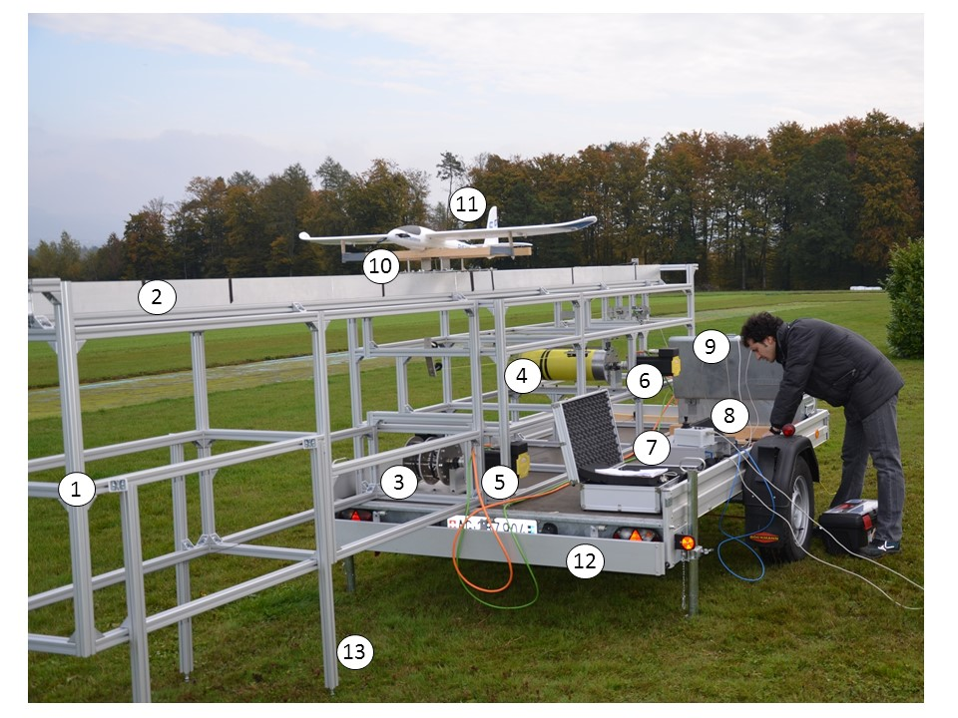

Fig. 1 - Overview of the prototype. (1) Aluminium frame, (2) rails, (3) slide drum, (4) winch, (5) slide motor, (6) winch motor, (7) real-time machine, (8) human-machine interface, (9) metal box with batteries, inverter and drives, (10) slide, (11) glider, (12) trailer, (13) support leg for the movable part of the frame.

For a detailed description of all the components of the prototype, its mechanical and electrical design, and the sensor and control aspects, the reference document is the **ABB Technical Note CH-RD 2015-211**. **We provide here only a very brief overview of the main parts for the sake of clarity and completeness**.

The prototype includes:

* a trailer where the prototype is installed;
* an aluminium frame to support all the components;
* a slide with rubber wheels;
* a model glider with a tether attachment mechanism;
* a manual remote controller for the glider;
* two rails to support the motion of the slide;
* two rotating drums, named “slide drum” and “winch”;
* a pair of tethers (“slide tethers”) to convert the rotation of the slide drum into a translation of the slide;
* a third tether (“winch tether”) coiled around the winch and connected to the glider;
* a series of pulleys to redirect the two tethers;
* a mass-spring system to partially decouple the rotation of the winch from the motion of the glider;
* a metal box containing the power supply and motor control parts: batteries, inverter, power converters, and two ABB drives;
* a real-time machine;
* a human-machine-interface composed by a joystick and five switches installed in a plastic box;
* cables connecting the various components to bring power and signal;
* a suitcase to transport the signal cables and the human-machine interface.

**Not provided with the prototype** is a laptop required to interact with the real-time machine and with the drives, see **ABB Technical Note CH-RD 2015-211** for the details on which software to install and how to setup a laptop to work with the prototype.

An overview of the main subsystems that compose the prototype and their mechanical, electrical (high power) and signal links is shown in Fig. 2.

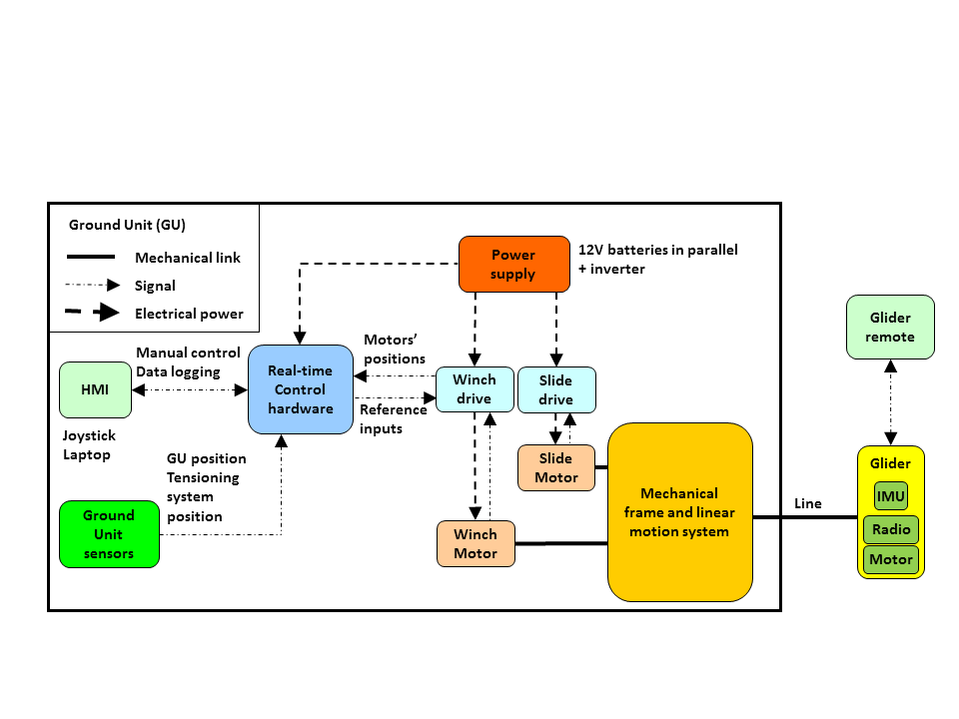

Fig. 2 - Layout of the prototype and its main interconnections

The layout of how the slide and winch tethers have to be set-up is depicted in Fig. 3.

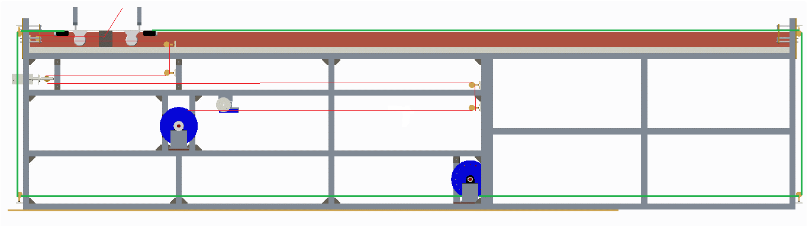

Fig. 3 – Computer rendering of the ground station with a highlight of the tethers. The slide tethers (green in the figure) are 3mm-thick and have a minimum breaking load of about 1 ton. The winch tether (red in the figure) is 2-mm thick and has a minimum breaking load of about 450 kg force. In the real prototype, the slide tethers are black and the winch tether is yellow.

An overview of the metal box with the power supply and the motor drives is shown in Fig. 4.

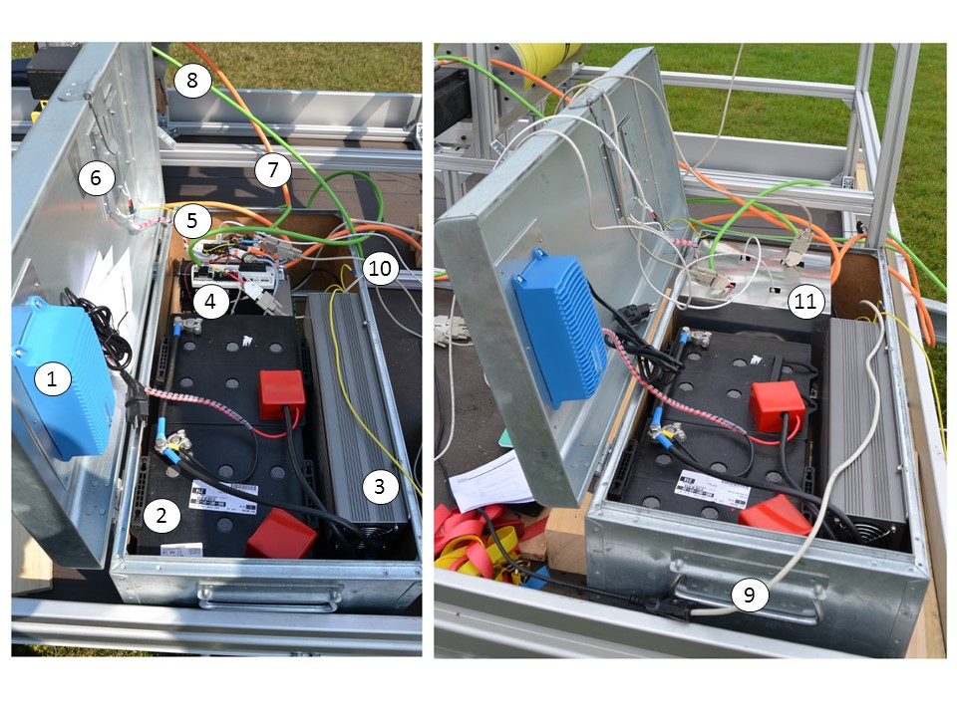

Fig. 4 – Metal box hosting (1) battery charger, (2) batteries, (3) inverter, (4) drive for the winch motor, (5) drive for the slide motor, (6) braking resistors, (7) power motor cables, (8) feedback motor cables, (9) 220V AC single phase supply for the real-time machine, (10) signal cables between drives and real-time machine, (11) protective metal plate

In addition to what shown in Fig. 4, the electric system of the prototype features:

* a key switch to connect/disconnect the batteries from the inverter and the AC supply (either from the inverter or from the network) from all the other electric devices;
* an emergency stop switch, which disconnects the main power supply from the drives and the other electrical devices;
* a green/red light that signals when the batteries and the main power are connected (red light) i.e. when the primary system supply is connected.

A scheme of the electrical system is available in Section 4.1.

# Operating principle and procedures

## Basic requirements for operation

**IMPORTANT**:

1. **DO NOT ATTEMPT TO OPERATE THE GROUND STATION WITHOUT THE PHYSICAL PRESENCE OF A TRAINED PERSON. THIS INCLUDES MOUNTING AND DISMOUNTING THE HARDWARE, CONNECTING THE ELECTRICAL PARTS, DEPLOYING AND RUNNING THE CONTROL SOFTWARE. A LIST OF TRAINED PERSONS IS REPORTED IN SECTION 4.2.**
2. **DO NOT ATTEMPT TO OPERATE THE MODEL GLIDER WITHOUT THE PHYSICAL PRESENCE OF A TRAINED PERSON. THIS INCLUDES MOUNTING AND DISMOUNTING THE GLIDER, CONNECTING THE ELECTRICAL PARTS, OPERATING THE REMOTE, ARMING THE GLIDER, TESTING THE SERVOS AND FLYING THE GLIDER. A LIST OF TRAINED PERSONS IS REPORTED IN SECTION 4.34.2.**
3. **WHEN OPERATING THE GROUND STATION WITHOUT THE GLIDER ATTACHED, A MINIMUM DISTANCE OF 1 METER HAS TO BE KEPT FROM BOTH ROTATING DRUMS.**
4. **WHEN OPERATING THE GROUND STATION WITH THE GLIDER ATTACHED AND FLYING, A MINIMUM DISTANCE OF 10 METERS HAS TO BE KEPT FROM THE GROUND STATION.**
5. **DO NOT ATTEMPT TO OPERATE THE GROUND STATION AND/OR THE GLIDER WITHOUT HAVING READ IN DETAIL THE RELATED TECHNICAL NOTE NUMBER CH-RD 2015-211.**
6. **ALWAYS WEAR SAFETY SHOES WHEN OPERATING THE PROTOTYPE.**

The prototype operation is divided in the following three contexts, each one with specific basic requirements:

1. **Prototype assembling for testing and dismounting for transportation**

The presence of at least three persons, of whom at least one trained to operate the ground station, is required. A car with a hook suitable for the prototype trailer is required for transportation and at least one person with driver’s license for passenger cars.

1. **Testing and tuning indoor (“Laboratory testing”) without the glider**

The presence of at least two persons, of whom at least one trained to operate the ground station, is required.

1. **Operation outdoor (“Field testing”) with the glider.**

The presence of at least three persons, of whom at least one trained to operate the ground station and at least one trained to operate the glider, is required. The two persons (trained for the ground station and trained for the glider) **cannot be the same person**.

In the following, we provide the operating instructions for each one of the contexts **a)**, **b)** and **c)** listed above.

## Prototype assembling for testing and dismounting for transportation

### Assembling the prototype for testing

**The following procedure must be followed when assembling the prototype:**

1. Place the prototype in a suitable position for testing. If indoor, this corresponds to the center of the available space in the room. If outdoor, this corresponds to a direction aligned with the prevalent wind speed, with the trailer’s back side facing the wind;
2. Secure the trailer by using its brakes and the pull-down supports;
3. Remove the straps that hold the two halves of the frame and the slide to the trailer;
4. Remove the wooden block employed for transportation;
5. Insert the slide into the fixed half of the rails, hold it by placing on the rails the wooden blocks employed for transportation;
6. Open the trailer back;
7. Unload the movable half of the frame by sliding it on the trailer’s surface (three persons are required). As soon as possible, pull down the aluminium legs before continuing to unload the half-frame. The latter has to be unloaded until the point where the ending part can move laterally to match with the fixed half of the frame;
8. Move laterally the moving part of the frame to match with the fixed half of the frame;
9. Attach the two halves of the frame with the four available M8 screws;
10. Pull down the remaining two aluminium legs, regulate all four legs to achieve a smooth alignment of the two halves of the rails, fix the legs with the available M8 screws;
11. Un-tie the slide tethers and connect them to the slide such that the tethers exit the slide drum from the same point in opposite directions;
12. Remove from the rails the wooden blocks holding the slide;
13. Tension the slide tether by adjusting the aluminium bars at the two ends of the rails;
14. Lay the real-time machine on the trailer;
15. Lay the laptop on the trailer:
16. Lay the human-machine-interface on the trailer;

**NOTE: the following steps have to be performed by a person trained to use the ground station.**

1. Open the metal box with the power supply and drives;
2. If field testing: plant the ground pole in the ground;
3. Connect the motor power cables (orange) and feedback cables (green) to the motors. The longer cables are for the motor connected to the slide drum, the shorter cables for the motor connected to the winch. Labels are also attached to the drives and to the cables;
4. Connect the 220VAC supply to the real-time machine;
5. Connect all the signal cables to their respective connectors, following the labels and the instructions provided by the trained person and in Technical Note number CH-RD 2015-211. These include:
   1. connection between the drives and the real-time machine (DB9 shielded cables);
   2. connection between the human-machine interface and the real-time machine (DB9 shielded cable);
   3. connection between the potentiometer and the real-time machine (DB9 shielded cable);
   4. connection between the real-time machine and the laptop (crossed Ethernet cable with Ethernet/USB adapter);
   5. connection between the drives and the real-time machine (USB cables).
6. If field testing: connect the drives’ block to the DC-AC inverter, making sure that the residual current protection is in place;
7. If laboratory testing: connect the drives’ block to the network single phase 220V AC supply;
8. Make sure the emergency stop switch is released;
9. Operate the key switch in order to connect the battery bank to the inverter and the main AC supply to all the electrical devices. The operation light turns red;
10. If laboratory testing: reset the residual protection device. The drives switch on and automatically enter idle mode;
11. If field testing: switch on the inverter and reset the residual protection device. The drives switch on and automatically enter idle mode;
12. Switch on the real-time machine;
13. If laboratory testing: go to Section 2.3
14. If field testing: go to Section 2.4.

### Dismounting the prototype for transportation

**The following procedure must be followed when dismounting the prototype for transportation:**

1. Switch off the real-time machine;
2. Disable the drives via software;
3. Operate the key switch in order to disconnect the battery bank from the inverter and the main AC power from all electrical devices, the operation light turns green;
4. If field testing: switch off the DC-AC inverter and disconnect the drives’ block from it;
5. If laboratory testing: disconnect the drives’ block from the network single phase 220V AC supply;
6. If field testing: Disconnect all the signal cables from their respective connectors and place them in the cabling suitcase. These include:
   1. connection between the drives and the real-time machine (DB9 shielded cables);
   2. connection between the human-machine interface and the real-time machine (DB9 shielded cable);
   3. connection between the potentiometer and the real-time machine (DB9 shielded cable);
   4. connection between the real-time machine and the laptop (crossed Ethernet cable with Ethernet/USB adapter);
   5. connection between the drives and the real-time machine (USB cables).
7. Disconnect the 220VAC supply from the real-time machine;
8. Disconnect the motor power cables (orange) and feedback cables (green) from the motors and lay them in the metal box;
9. If field testing: remove the ground pole from the ground and place it in the metal box;
10. Close the metal box;
11. Remove the human-machine-interface from the trailer, place it in the suitcase;
12. Remove the laptop from the trailer:
13. Remove the real-time machine from the trailer;
14. Block the slide on the fixed half of the frame by laying wooden bars on the rails;
15. Detach the slide tethers from the slide, coil them and tie them to the aluminium frame;
16. If the winch line was free, coil it on the winch and fix it to the winch surfaces with adhesive tape;
17. Block the winch rotation by using cardboard inserts between the drum and its supports;
18. Detach the movable half of the frame from the fixed half;
19. Pull up the middle two aluminium legs of the movable half of the frame;
20. Move laterally the moving part of the frame to the side of the fixed half of the frame;
21. Load on the trailer the movable half of the frame by sliding it on the trailer’s surface (three persons are required). When needed, pull up the aluminium legs;
22. Remove the slide from the fixed half of the frame and lay it on the trailer;
23. Insert the wooden parts between the two halves of the frame and between the movable half and the trailer flanks;
24. Close the trailer’s back;
25. Apply and tighten the straps used for transportation to fix the movable half of the trailer and the metal box.

## Laboratory testing

The laboratory testing of the prototype is useful to setup and try functionalities like communication, measurement, logging and control without the need to move to the testing field. Moreover, batteries can be re-charged when the prototype is stored indoor. When testing the prototype indoor, the power supply must be taken from the network to ensure proper grounding (see Section 2.2.1). When testing the prototype indoor, the glider is not required. Three main situations can occur in laboratory testing:

1. Development and debugging mode, where for example new sensors, communication devices, control functions are used for the first time;
2. Tuning system functionalities, where the correct functioning of the measurement and control system has been already tested and parameters need to be tuned (e.g. slide travel during take-off, winch reeling strategy, etc.)
3. Battery charging

The operating procedures for each of these situations are described in the next sections.

### Development and debugging mode

**The following procedure must be followed in development and debugging mode:**

1. Follow the procedure in Section 2.2.1 to setup the prototype for indoor operation;
2. Secure the winch tether to the winch drum by means of adhesive tape;
3. Detach the slide tethers from the slide and coil them around the slide drum such that the drum rotates freely without moving the slide;
4. Ensure that no person is within 1 meter from any one of the rotating machines;
5. Ensure that no external object (e.g. tools) are present within 1 meter from any one of the rotating machines;

**NOTE: steps from 6. to 9. have to be performed by a person trained to use the ground station.**

1. If the motors need to be operated: load the low-level control software to the drives and start them using the Mint WorkBench software (see Technical Note n. CH-RD 2015-211 for details);
2. If the real-time machine needs to be used: build and download the control software to the real-time machine (see Technical Note n. CH-RD 2015-211 for details);
3. Carry out the planned/desired tests by starting the real-time machine.
4. After testing: stop the real-time machine, acquire the log on the laptop;
5. Switch-off the real-time machine
6. Disable the drives using the Mint WorkBench software;
7. Switch-off the power supply by disconnecting it from the network.

### Tuning system functionalities

**The following procedure must be followed when tuning the ground station functionalities:**

1. Follow the procedure in Section 2.2.1 to setup the prototype for indoor operation
2. If the winch reeling strategy with potentiometer is not to be tested: secure the winch tether to the winch drum by means of adhesive tape;
3. If the winch reeling strategy with potentiometer is to be tested: pass the winch line through all the pulleys up to the slide, attach a wooden bar to the winch line to prevent it to slip back inside the frame from the exit point on the slide;
4. Ensure that no person is within 1 meter from any one of the rotating machines;
5. Ensure that no external object (e.g. tools) is present within 1 meter from any one of the rotating machines and the lines paths (both slide lines and winch line);

**NOTE: steps from 6. to 11. have to be performed by a person trained to use the ground station.**

1. Ensure that the slide is positioned in the middle of the rails;
2. If the winch reeling strategy with potentiometer is to be tested: ensure that the winch line is not sagging;
3. Load the low-level control software to the drives and start them using the Mint WorkBench software (see Technical Note n. CH-RD 2015-211 for details);
4. Build and download the control software to the real-time machine (see Technical Note n. CH-RD 2015-211 for details);
5. Carry out the planned/desired tests by starting the real-time machine.
6. After testing: stop the real-time machine, acquire the log on the laptop;
7. Switch-off the real-time machine
8. Disable the drives using the Mint WorkBench software;
9. Switch-off the power supply by disconnecting it from the network.

### Battery charging

**The following procedure must be followed when charging the ground station batteries:**

1. With the power supply module disconnected by the key switch (green light), plug the battery charger into a 220VAC socket;
2. Leave the battery charger connected until when it shows a steady green light (typically after about one day), i.e. when batteries are fully charged;
3. Disconnect the battery charger from the network.

## Field testing

Field testing of the prototype is the main intended operating mode of the system and implies transportation of the prototype to the testing field and assembling it for outdoor testing. Since at least three persons are required, of which at least two that have been trained to use the ground station and the glider, respectively, and since the total transportation, assembling and dismounting time is around 1.5 hours, field testing should be optimized to acquire data to advance the research project. **Thus, no testing of basic functionalities or tuning of the ground station controllers should be normally carried out during field testing.** When testing the prototype outdoor, the glider is required. The normal procedure for field testing is divided into **four subsequent phases**:

1. Ground station initial test;
2. Glider setup and flight without ground station;
3. Un-tethered launch and landing
4. Tethered launch and landing

The operating procedures for each one of these phases are described in the next sections. **When finished testing, the procedure in Section 2.2.2 has to be followed.**

### Ground station initial test

**The following procedure must be followed to carry out the initial test of the ground station:**

1. Follow the procedure in Section 2.2.1 to setup the prototype for outdoor operation;
2. Secure the winch tether to the winch drum by means of adhesive tape;
3. Ensure that no person is within 1 meter from any one of the rotating machines;
4. Ensure that no external object (e.g. tools) is present within 1 meter from any one of the rotating machines and the lines paths (both slide lines and winch line);

**NOTE: the next steps have to be performed by a person trained to use the ground station.**

1. Ensure that the slide is positioned in the middle of the rails;
2. Load the low-level control software to the drives and start them using the Mint WorkBench software (see Technical Note n. CH-RD 2015-211 for details);
3. Download the control software to the real-time machine (see Technical Note n. CH-RD 2015-211 for details);
4. Start the real-time machine and test the correct functioning of the ground station, including a take-off manoeuvre and the manual winch speed control;
5. After testing: stop the real-time machine, acquire the log on the laptop, check the correctness of all the variables;

### Glider setup and flight without ground station

**The following procedure must be followed to setup and fly the glider. NOTE: these steps have to be performed by a person trained to use the glider.**

1. The gliders are transported and stocked with the wings disassembled. Assemble the wings and the body ensuring that the carbon rod is present in the wings (fibre glass rod for the Easyglider). Stop half-way through the carbon rod;
2. Insert the cables of the servos in the body. When flying without autopilot, the Pitot tube does not need to be connected (4 wires cable);
3. Fully assemble the wings on the body and connect the cables to the receiver in the following order:
4. -Ch1 : Aileron 1
5. -Ch2 : Elevator
6. -Ch3 : Motor
7. -Ch4 : Rudder
8. -Ch5 : Release Mechanism
9. -Ch6 : Flaps
10. -Ch7 : Aileron 2

The ground pin on the receiver is indicated by a (-);

1. With the battery not connected to the controller, check the balance of the glider. The centre of gravity should be at 67mm from the leading edge for the Yoyo glider and at 70mm for the Easyglider. The release mechanism should coincide with the centre of gravity +-5mm;
2. Turn on the radio-command and ensure that the right model is selected and that the joystick handle corresponding to the motor is at minimum. When flying without autopilot, the pilot can flip the ‘en.motor’ interrupter which disable or enable the joysticks handle corresponding to the motor;
3. Connect the battery to the controller. It will emit a series of tones ending by a long one when ready. If it emits an intermittent short tone, it means that it receives no signal from the receiver or that the joystick handle corresponding to the motor is not at the minimum. The receiver will display a green light if it receives correct signal from the radio, red if not;
4. Check the correct functioning of the control surfaces: correct direction of motion, health of the servomotors, correct return to the neutral position;
5. Close the glider’s lid and from this point on, no one is allowed to stand in front or next to the propeller. The safe position is behind the propeller and the glider;
6. Check the correct functioning of the motor by accelerating until full speed;
7. Prior to the flight the pilot informs the persons around that they must stand behind him at any point of the flight until complete landing. Access to the runway is only permitted with the agreement of the pilot.

### Un-tethered take-off and landing

**The following procedure must be followed to carry out an un-tethered take-off and landing:**

1. Follow the procedures in Sections 2.2.1, 2.4.1 and 2.4.2 to setup and carry out the initial test of the prototype and the glider;
2. Ensure that no external object (e.g. tools) is present within 1 meter from any of the rotating machines and the lines paths (both slide lines and winch line);
3. Install the glider on the slide;
4. Ensure that no person is within 1 meter from any one of the rotating machines;

**NOTE: the next steps have to be performed by a person trained to use the ground station in combination with a person trained to use the glider.**

1. Ensure that the slide is positioned in the middle of the rails;
2. Load the low-level control software to the drives and start them using the Mint WorkBench software (see Technical Note n. CH-RD 2015-211 for details);
3. Download the control software to the real-time machine (see Technical Note n. CH-RD 2015-211 for details);
4. Start the real-time machine, carry out the un-tethered take-off manoeuvre, fly the glider and land on the runway;
5. Stop the real-time machine, acquire the log on the laptop;

### Tethered take-off and landing

**The following procedure must be followed to carry out a tethered take-off and landing:**

1. Follow the procedures in Sections 2.2.1, 2.4.1, 2.4.2 and 2.4.3 to setup and carry out the initial test of the prototype and the glider and to carry out an un-tethered take-off and landing;
2. Remove the adhesive tape from the winch tether, slowly reel-out the tether and pass it through all the pulleys up to the exit point on the slide, and connect it to the glider;
3. Install the glider on the slide;
4. Ensure that no external object (e.g. tools) is present within 1 meter from any one of the rotating machines and the lines paths (both slide lines and winch line);
5. Ensure that no person is within 1 meter from any one of the rotating machines;

**NOTE: the next steps have to be performed by a person trained to use the ground station in combination with a person trained to use the glider.**

1. Ensure that the slide is positioned in the middle of the rails;
2. Ensure that the winch line is not sagging and that it is correctly installed;
3. Load the low-level control software to the drives and start them using the Mint WorkBench software (see Technical Note n. CH-RD 2015-211 for details);
4. Download the control software to the real-time machine (see Technical Note n. CH-RD 2015-211 for details);
5. Start the real-time machine;
6. Ensure that no person is within 10 meters from the ground station;
7. Carry out the tethered take-off manoeuvre and fly the glider;
8. Carry out the tethered landing manoeuvre, or alternatively detach the glider from the line;
9. After landing: stop the real-time machine, acquire the log on the laptop.

# Safety aspects: risks and safety measures

## Risks and safety measures related to prototype transportation

|  |  |
| --- | --- |
| **Risk description** | **Safety measures** |
| Prototype part is loose and drops out of the trailer | The prototype is well-fixed to the trailer by means of the straps.  All bolts have cut washers to provide pre-tensioning and avoid unscrewing due to vibration in road transportation.  When moving to the testing field, two vehicles are used, the first one carrying the trailer, the second one following at a safety distance.  If notwithstanding the safety measures a part detaches and drops out, the follower car stops to ensure no damage is made, and alerts the leading car to also stop in case the event was unnoticed. |
| Prototype line unwinds and hangs out of the trailer | The lines are tightly tied to the prototype frame during transportation to prevent unwinding.  When moving to the testing field, two vehicles are used, the first one carrying the trailer, the second one following at a safety distance.  If notwithstanding the safety measures one line unwinds and hangs out of the trailer, the follower car immediately alerts the leading car to stop. |

## Risks and safety measures related to prototype assembling and dismounting for transportation

|  |  |
| --- | --- |
| **Risk description** | **Safety measures** |
| Mechanical component or part of the frame falls and/or hits the people assembling the prototype | All the people working on the prototype must be trained to work in the lab, wear safety shoes and take the usual precautions.  The presence of at least three persons, of whom at least one trained to operate the ground station, is required when assembling and dismounting. |
| Wrong connection of cables between the motor and the drives | The power and signal cables cannot be swapped due to different colours and connectors.  The winch cables cannot be attached to the slide motor because they are too short.  Thus, there is only one possible way to attach the cables to all motors. |
| Wrong connection of cables between the drives and the real-time machine | The cable connectors are all labelled to avoid connection errors.  Connections have to be done by a person trained to use the ground station.  In case the cables are wrongly connected notwithstanding the safety measures, following the procedures of Section 2 ensures that the mistake is spotted with no harming risks when first testing the prototype, since the winch motor will rotate freely, instead of the slide motor. Then the operator can stop the real-time machine and the drives and correct the connections. |
| Wrong software downloaded to the drives | Only one version of each software (for the slide and for the winch) is kept in the project repository, and the filenames clearly indicate which one is for the slide, and which one for the winch.  Drive software download has to be done by a person trained to use the ground station.  In case the control programs are wrongly downloaded (swapped) notwithstanding the safety measures, following the procedures of Section 2 ensures that the mistake is spotted with no harming risks when first testing the prototype, since the winch motor will rotate freely and it will be in position control instead of speed control. Then the operator can stop the real-time machine and the drives and correct the software downloading. |

## Risks and safety measures related to prototype operation

|  |  |
| --- | --- |
| **Risk description** | **Safety measures** |
| Translating part hits the people operating the prototype | At least 1m of clearance with no glider and at least 10m of clearance with glider have to be observed by the personnel when operating the prototype. This ensures that no translating part can hit the persons.  If the rules are not observed, switching off the enabling button on the human-machine interface immediately disables the motor torques.  Pressing the emergency stop button also disables all electric components, hence the motor torques, too. |
| Rotating part hits or catches the people operating the prototype | At least 1m of clearance with no glider and at least 10m of clearance with glider have to be observed by the personnel when operating the prototype. This ensures that no rotating part can hit or catch the persons.  If the rules are not observed, switching off the enabling button on the human-machine interface immediately disables the motor torques.  Pressing the emergency stop button also disables all electric components, hence the motor torques, too. |
| Glider hits the people operating the prototype | At least 10m of clearance from the ground station when operating with the glider attached have to be observed by the personnel. This ensures that the glider cannot hit the persons.  The glider has to be operated by a trained person. |
| Line entangling with other components | In some situations, the winch line can entangle. If this happens, stopping the winch with the human-machine interface prevents the entanglement from worsening. Then, the prototype has to be stopped, the drives disabled, and the entanglement resolved manually before continuing operation. |
| Line entangling with people | At least 10m of from the ground station when operating with the glider attached have to be observed by the personnel. This ensures that no line entangling with people can occur.  If the rules are not observed, switching off the enabling button on the human-machine interface immediately disables the motor torques.  Pressing the emergency stop button also disables all electric components, hence the motor torques, too. |
| Remote control malfunctioning | In the very unlikely case of remote control malfunctioning, the glider will keep the last commands and switch off the propeller after a certain time. This will lead to crash. This situation is no different from that of a similar problem happening with standard model glider flight. Damage to persons is highly unlikely. The person operating the glider is covered by insurance for eventual damage to things. |
| Drive malfunctioning | Depending on the type of drive malfunctioning, different problems can occur. At least 1m of clearance with no glider and at least 10m of clearance with glider have to be observed by the personnel when operating the prototype. This ensures that no harm to people occur.  The design of the ground station is such that all its components are held together with forces larger than what the motor can possibly deliver. This avoids damage to major components in the prototype.  When situation is safe, switching off the power supply will cause the drives to switch off as well.  Pressing the emergency stop button also disables all electric components, hence the motor torques, too. |
| Real-time machine malfunctioning | Depending on the type of malfunctioning, different problems can occur. At least 1m of clearance with no glider and at least 10m of clearance with glider have to be observed by the personnel when operating the prototype. This ensures that no harm to people occur.  The design of the ground station is such that all its components are held together with forces larger than what the motor can possibly deliver. This avoids damage to major components in the prototype.  When situation is safe, switching off the power supply switches off the real-time machine and the drives. Disconnecting or switching off the real-time machine will also disable the motor torques.  Pressing the emergency stop button also disables all electric components, hence the motor torques, too. |
| Not proper grounding of the electrical equipment | Laboratory use: not allowed to use the prototype on batteries, always use power supply from the grid with the residual current protection device to ensure proper grounding.  Field use: ensure that the grounding cable with the terminal spike is fully inserted in the ground (see procedure in Section 2.2.1). |

# Appendix

## Scheme of the electrical design of the ground station

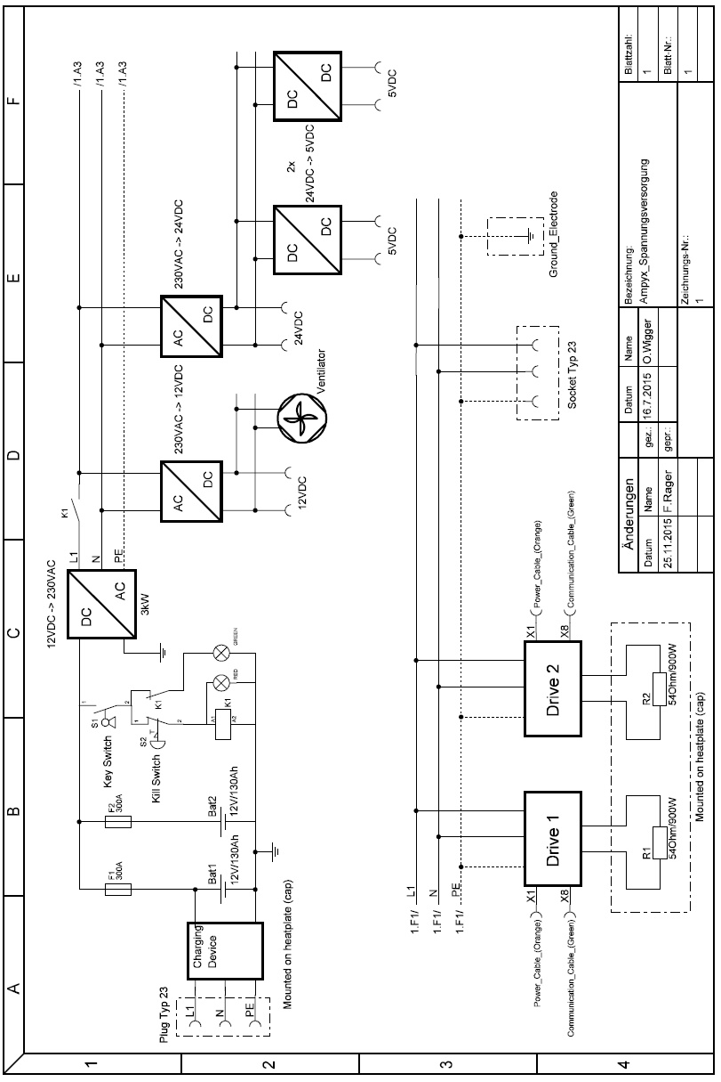

## List of persons trained to operate the ground station

Lorenzo Fagiano (CHCRC.P2)

## List of persons trained to operate the glider

Felix Rager (CHCRC.P2)

Eric Nguyen-Van (CHCRC.P2)